How to Provide Access in PDM Application based on PPM Request

**Document History**

|  |  |  |
| --- | --- | --- |
| **Version number** | **Update by and date** | **Remarks** |
| **V.1.0** | Tahmid/ 9th January, 2017 | Initial document prepared |
|  |  |  |
|  |  |  |
|  |  |  |
|  |  |  |
|  |  |  |

The purpose of this document is to describe the whole set of operations a technical approver goes through while fulfilling a PPM request. This document particularly targets to elucidate following operations:

1. Allowing viewing groups
2. Allowing User/Owner groups
3. Providing business roles
4. Allowing access to a market area
5. Allowing access to different ERP companies and job description &
6. Creating new user

**Step 1:** Analyze the request:

Technical approvers are notified about PPM requests through email notifications. A typical PPM request mail content looks like the following image:

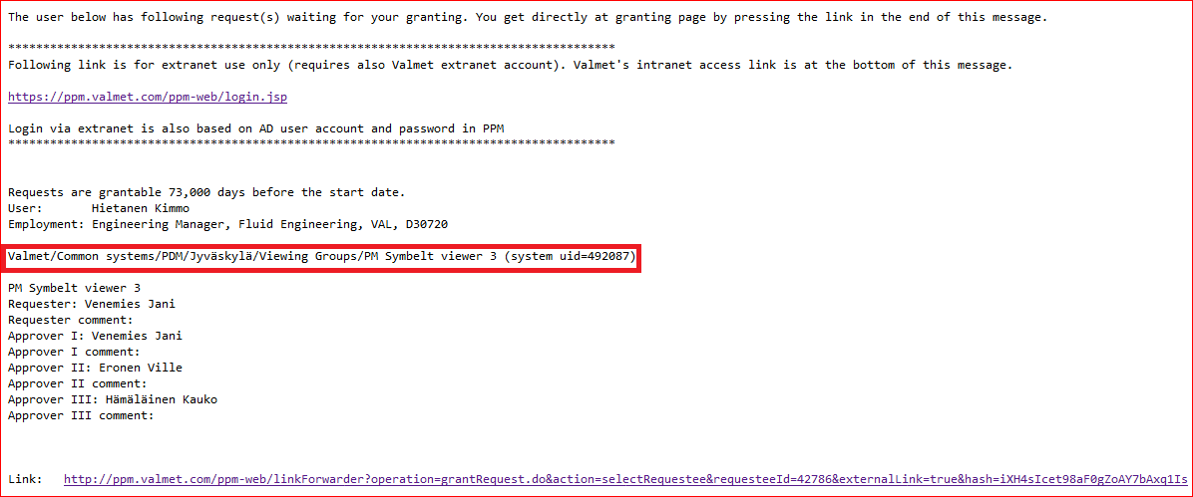

Check the red marked text in the mail content. There might be following types of requests:

1. Viewing group access:

**Valmet/Common systems/PDM/Jyväskylä/Viewing Groups/PM Symbelt viewer 3 (system uid=492087)**

1. Owner group access:

**Valmet/Common systems/PDM/Järvenpää + Turku/Owner groups/Coating head/Coating head(system uid=492087)**

1. Viewable ERP company access:

**Valmet/Common systems/PDM/SHA/ERP Company Data/Viewable ERP companies (system uid=492087)**

1. Allowed ERP company access:

**Valmet/Common systems/PDM/Service/ERP Company Data/ERP companies (system uid=490440)**

1. Market Area access:

**Valmet/Common systems/PDM/Järvenpää + Turku/Market Area/World (system uid=492087)**

**Step 2:** Open the request in PPM using the link in the bottom of the mail and check the request in detail.

Login to PDM and go to the **Administration tools** site.

Execute following steps to locate the user in PDM:

1. Select **All** in **Default site** field.
2. Type in the Uid fetched from mail in the Person number field.
3. Click the Search button.

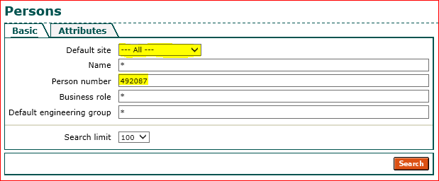

If there is no active user account found in PDM for the specified UID, then go to new user creation step.

If user with the specified person number is available in PDM, then the search result will be like the following image below.

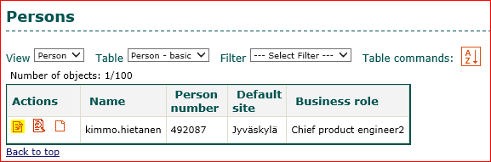

**Step 4:** Provide the required access:

Click on the Yellow marked edit button as shown in the picture above. It will launch the user details in edit mode.

Check the image below to understand PPM request mapping in PDM application.

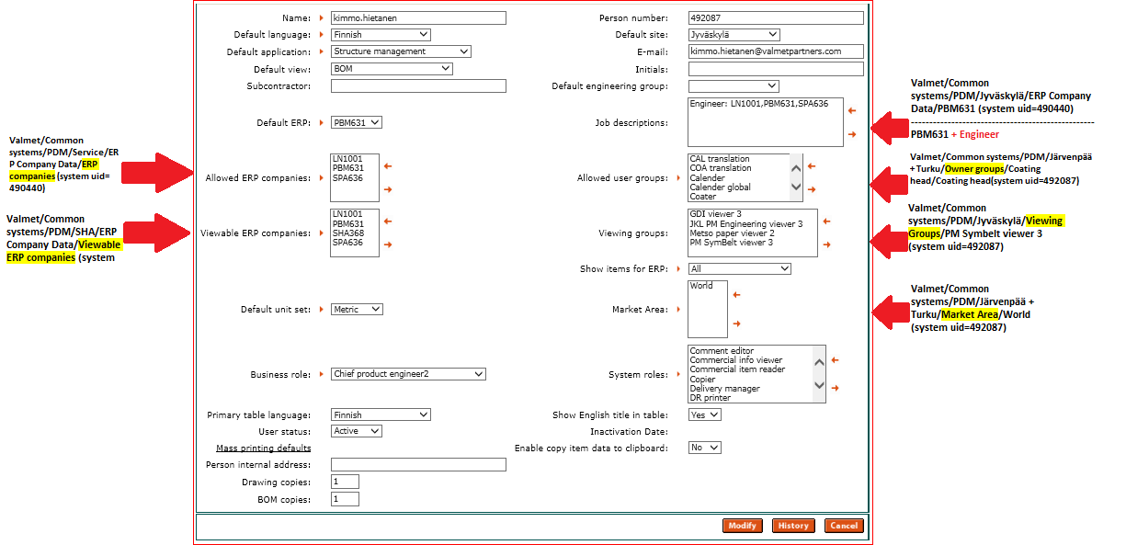

For **Job description** field in PDM, there is no specific field in PPM. As a result, **Job description** might get added as part of other requests. Check the following image:

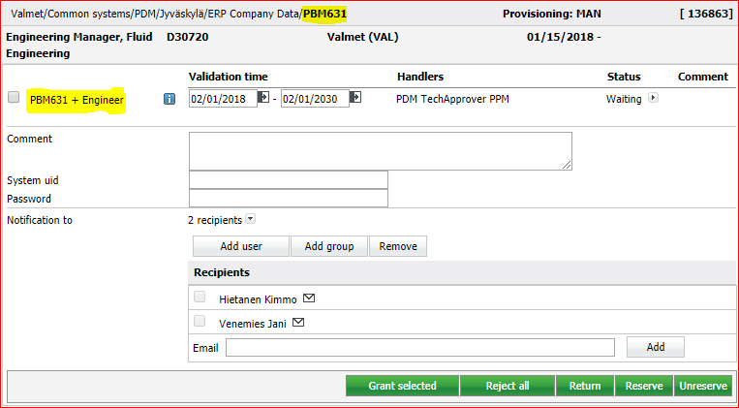

Most of the times, Job description is added as part of Allowed ERP company request. Since the request in PPM was **PBM631 + Engineer**, selections like the below image should be done.

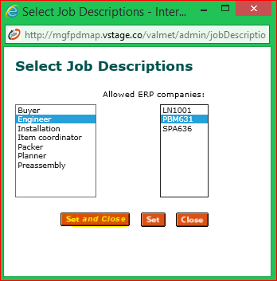

Sometimes there might be requests containing nested requests in PPM. Technical approver needs to update/check those too along with the main request. For instance, check the following image :

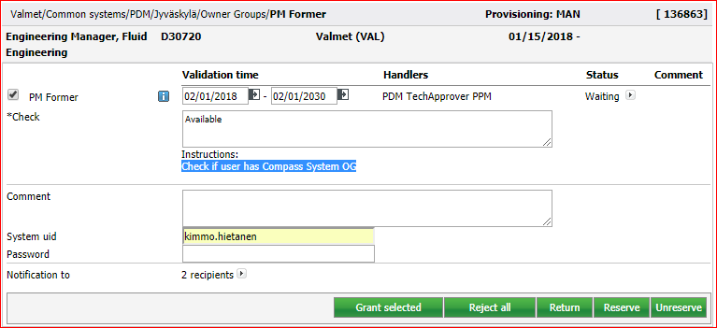

Here, the requester is asking to check if the user has Compass system owner group access or not. These requests should be fulfilled along with the main request. While working on such a request, during granting, **\*Check field** needs to be filled with resolution text.

If no user account is available in PDM application, then check rest of the requests for the same user in PPM.

If there is no (user ID) such request, then keep the request in queue for few days and then reject it.

If there is a request asking for creating user account in PDM, then create it.

**Create New User**

Check the following image from PPM request.

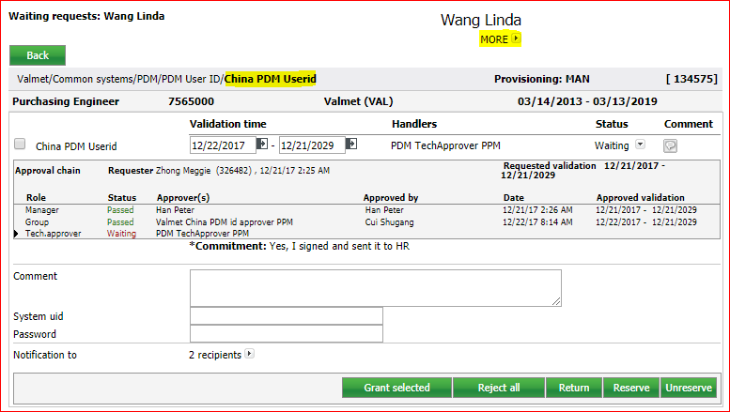

Click on the MORE link for user details and fetch **UserID** and **Email** from here. Check **Location** as well to use defaults for mandatory fields if request lacks some necessary information.

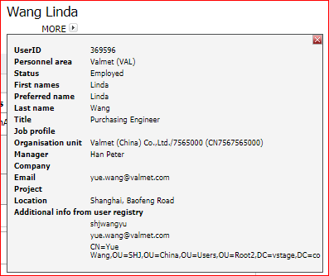

Go to PDM application’s Administration site. Since there is no straight forward way in PDM for creating user, we need to copy another existing user to create a new one. Hence, search for an existing user and click on the Yellow marked button to create new user from the search result page.

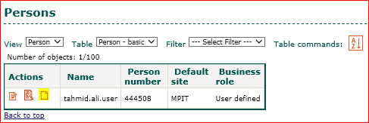

Now for safety purpose, **clear all possible fields** in the **Create person details** page so that no unwanted accesses are given to new user.

Now fill up the form. There are some fields marked with right arrow, which are mandatory while creating new user.

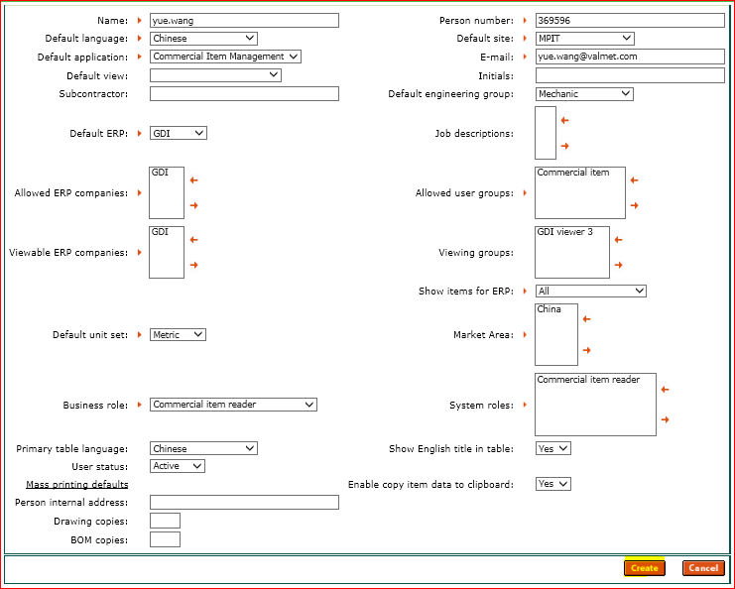

Now click the Create button. User will be created in PDM.

NOTE: Sometimes, there might be incomplete requests in PPM. i.e. no data for some mandatory fields. In that case, follow following document to fill up the defaults.